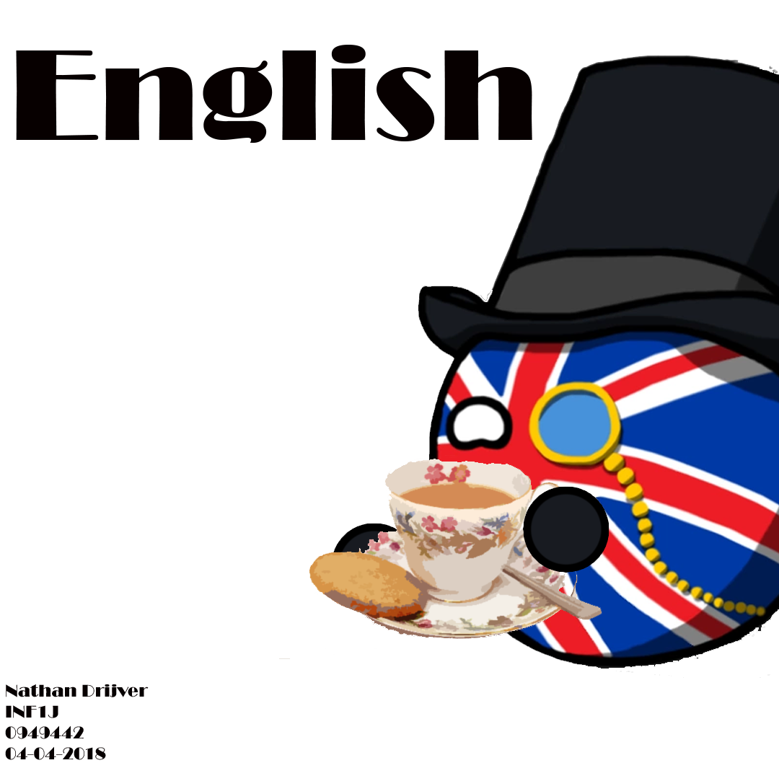

**English Block**

**Heads up**

This block consists of proving writing,grammar, spelling, speaking, listening and reading. To demonstrate that I accomplished these goals what follows is a summary of videos and a text based around computer sciences, additionally, I have performed some tests on cambridgeenglish.org and discussed Project 3: Data Visualisation with someone. Due to these tests providing multiple categories of results/analysis, I will be providing categorised evidence.

**UML Video Summary (writing, listening, grammar & spelling)** **3**

**AI Text Summary (writing, reading, grammar & spelling)** **13**

**Cambridge English Tests** **15**

Vocab and grammar 15

Informal/Formal 17

which clause 18

Speaking and Reading 19

#### **UML Video Summary** (writing, listening, grammar & spelling)

UML Class Diagrams are taken from [here](https://www.youtube.com/watch?v=UI6lqHOVHic), in the even that the video has been deleted, I have mirrored it [here](https://www.youtube.com/watch?v=lXn-ZQy6ihE&feature=youtu.be)

**Basic Characteristics:**

We are building a zoo,

In our class diagram we’d like to describe the things that are depicted in a zoo.

A zoo has, for example, animals. In a UML class diagram you’d write this down by making a class for it that accounts for all animals in the zoo.

You then need to give them attributes, which are things that allow you to recognise the objects in the class, preferably with an integer that describes the unique place in the class diagram which would be called an ID. A name to recognise the animal and the age so we might predict when it will die.

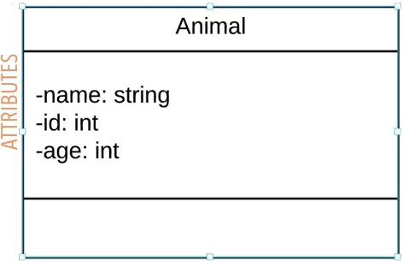

Next on the list are Methods, also known as operations or functions. They allow you to specify any behavioural feature of a class.

Our animals, for example, might want to eat or they’ll starve. So we could make a function for the animal class where we allow them to eat. We might also want to edit the attributes. Ruth, a sloth, might be renamed to Robert. Although it is obvious that the animals won’t go up and rename themselves in a database, it doesn’t mean we cant use it for the class. The rename function specifies the behaviour of the class, not necessarily the thing that the class is named after.

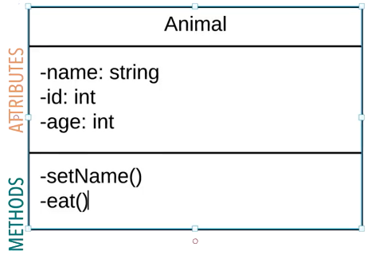

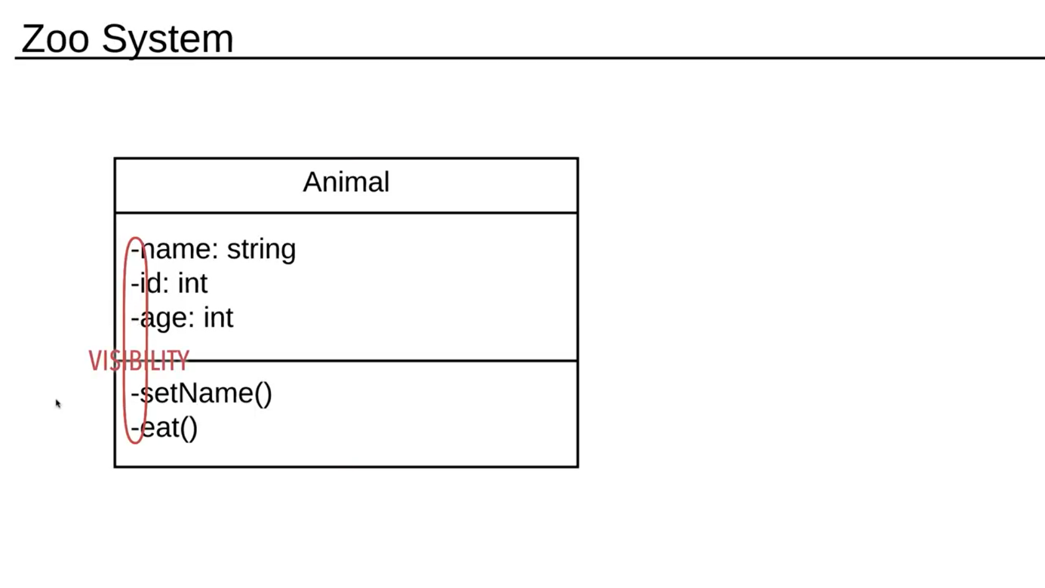

We can also specify what attributes or methods can be used by other classes or subclasses. This is done by assigning visibility. Access to a class is either limited or unlimited by writing placing a symbol (–, +, # or ~) before every attribute.

A minus sign (-) means that the attribute is *Private*. If an attribute or method is Private no other class or subclass in the diagram can use the attribute or method.

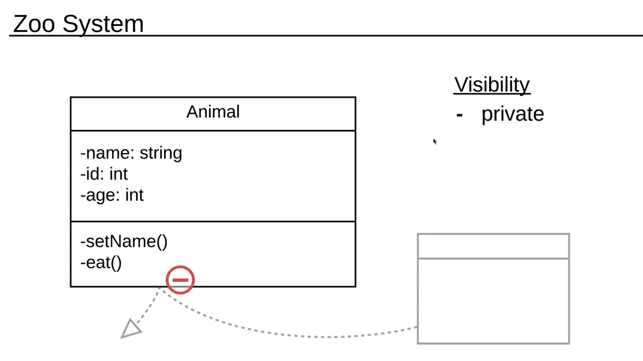

A plus sign (+) means that the attribute is *Public.* If an attribute or method is Public then every other class or subclass in the diagram can use that attribute or method.

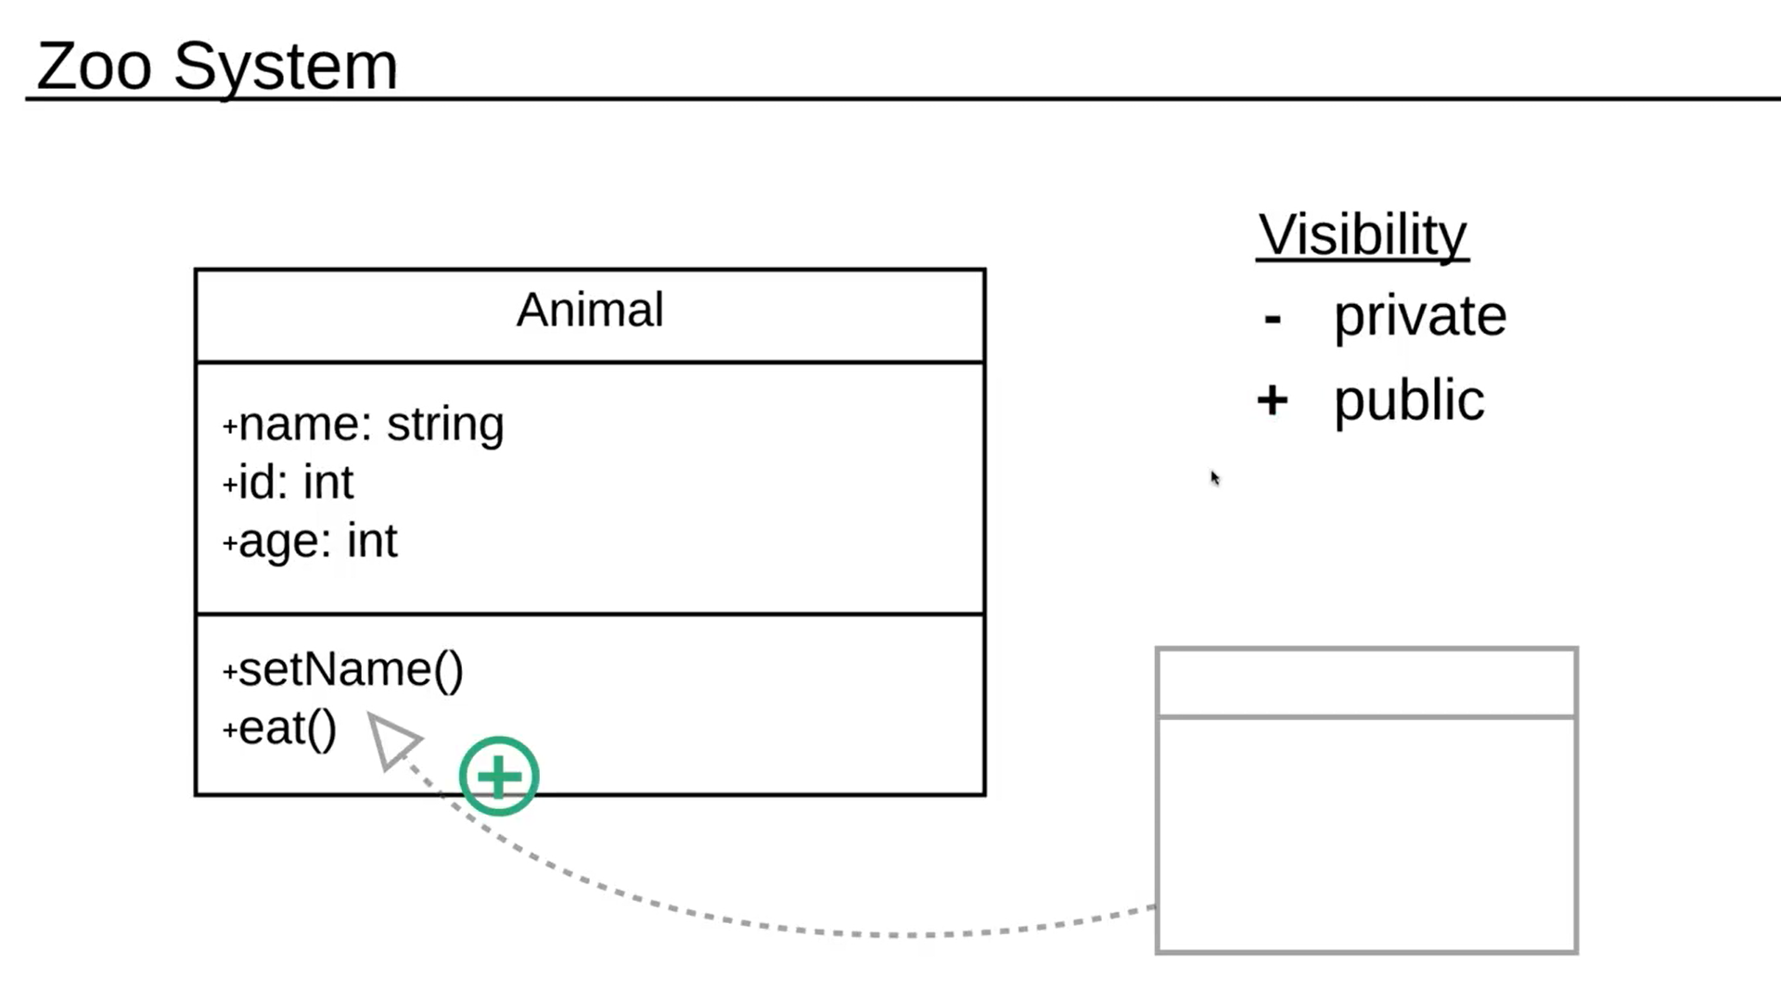

A hashtag (#) specifies that the attribute is *Protected*. If an attribute or method is Protected then only subclasses of the class containing the Protected attribute may use that attribute or method and all other classes cannot.

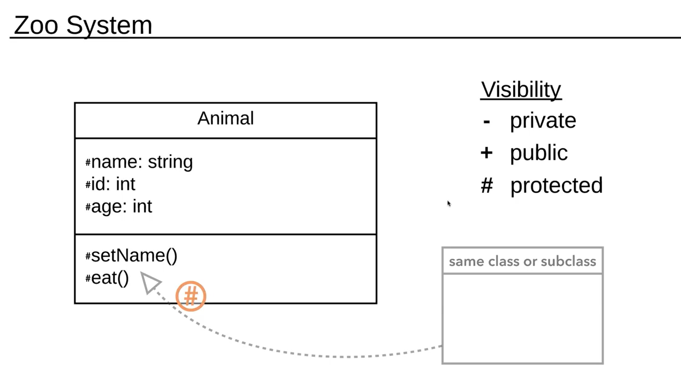

A tilda (~) symbol specifies that the attribute is *Packaged*. If an attribute or method is Packaged then all classes or subclasses within the class package are able to use it.

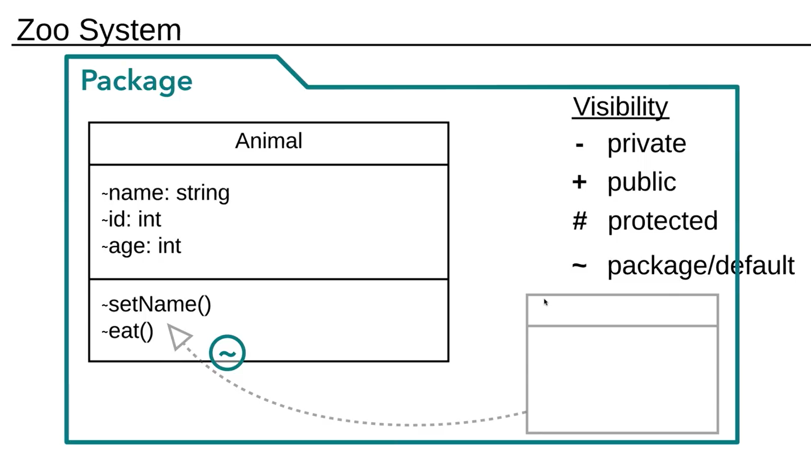

**Inheritance**:

In our zoo we want to distinguish between three very important animals. The tortoise, the otter and the slow loris. To do this we make 3 new classes for every animal. These classes need to be linked up to the class **Animal**, which, in this case, is the superclass (or parent class). We want all of the attributes from **Animal** to come to the 3 smaller classes.

We can do this using inheritance, as depicted in the image below it is an arrow that has a white arrowtip. The subclass or child class points to the superclass or parent class with this inheritance arrow and inherits all attributes from **Animal**.

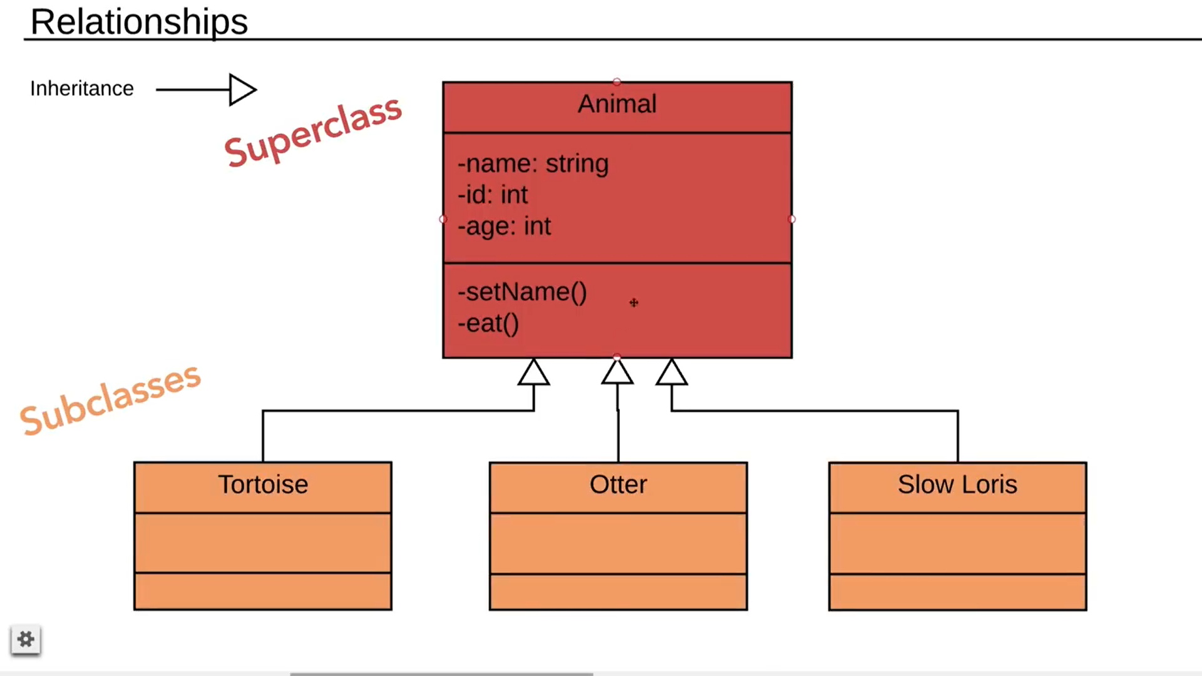

These Subclasses or child classes can also have their own attributes. The otter for example could have an attribute called whisker length, the same thing is also true for methods.

You can also now change one thing for **Animal** to have it change for all subclasses.

In the zoo diagram we now have an **Animal** class, but we hardly ever use it since you can use the methods from **Animal** in the subclasses: tortoise, otter and slow loris. This means that the parent class is simply there for simplification or better yet, Abstraction. Abstractions help keep the diagram orderly and makes sure that you don’t repeat yourself. Abstractions are specified with either *italics* or <<>> in the class names.

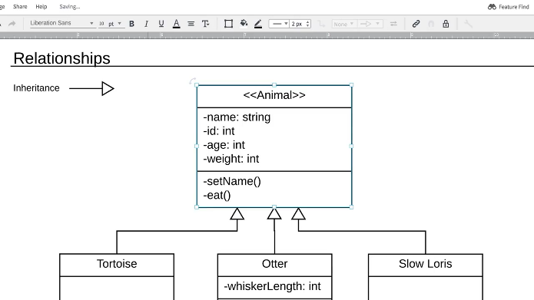

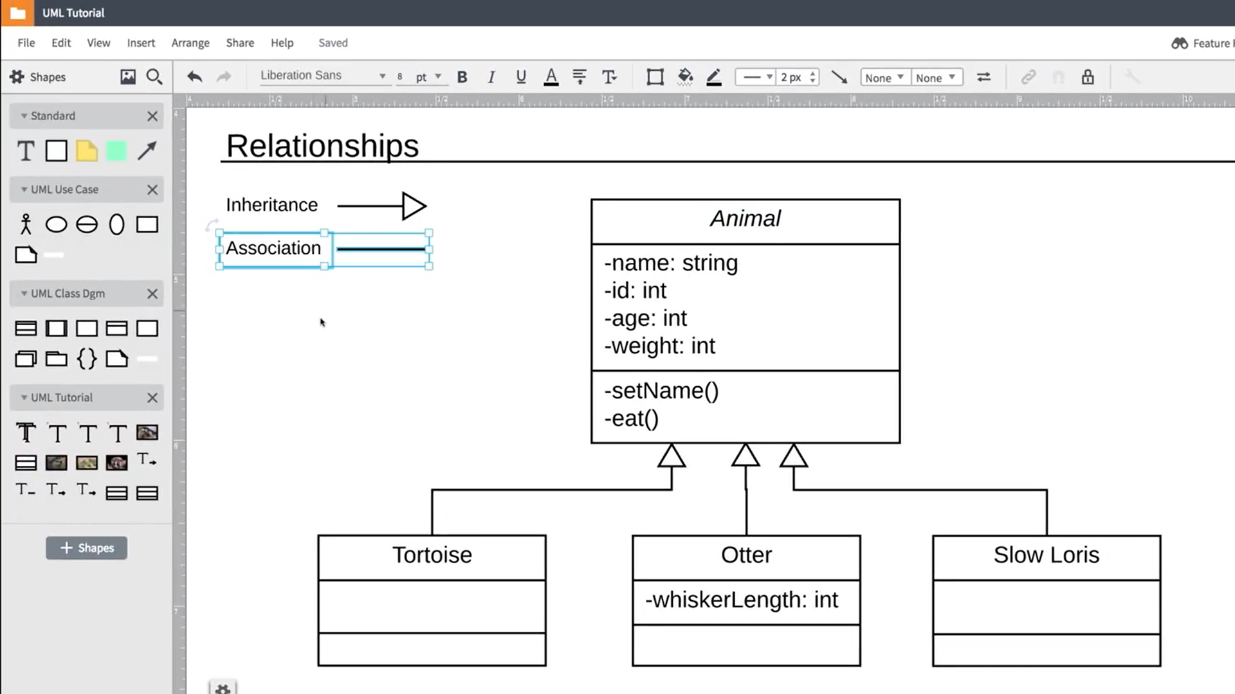

**Association:**

Association is a form of relationship, much like Inheritance but it serves a different purpose, hence the difference in image, one is a line and the other a white arrow. Associations are simply the way that one class relates to another class. For example: otters eat sea urchins, we put a simple association line in between them and give it a name, **eats** in this case.

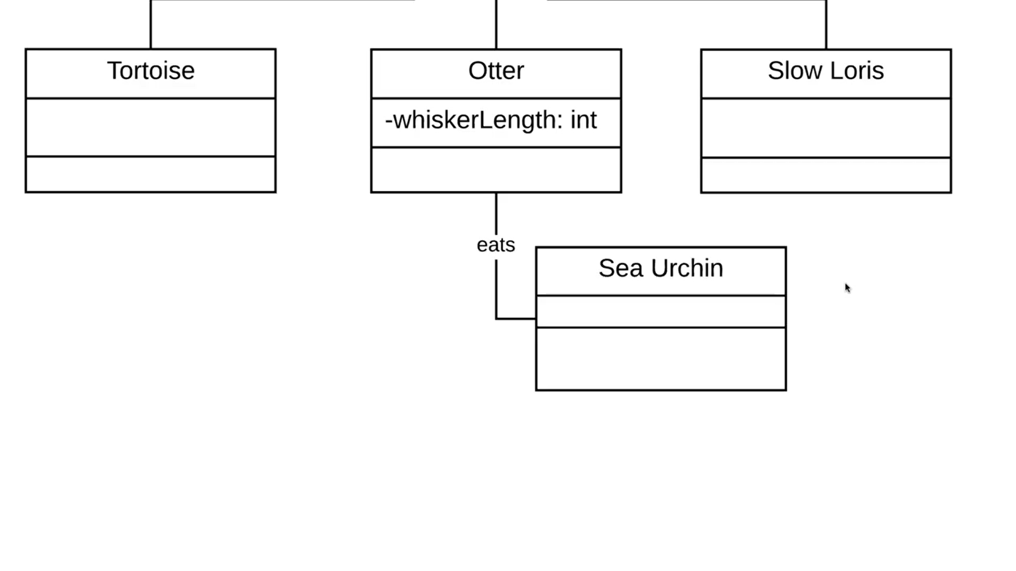

The next relationship is *Aggregation*.

In our example, the zoo, we have a class called tortoise. A group of tortoises is called a creep, any individual tortoise can be a part of the creep but isn’t forced to be, it can leave at any point. To indicate that a part exists outside of the whole. You use an Aggregation.

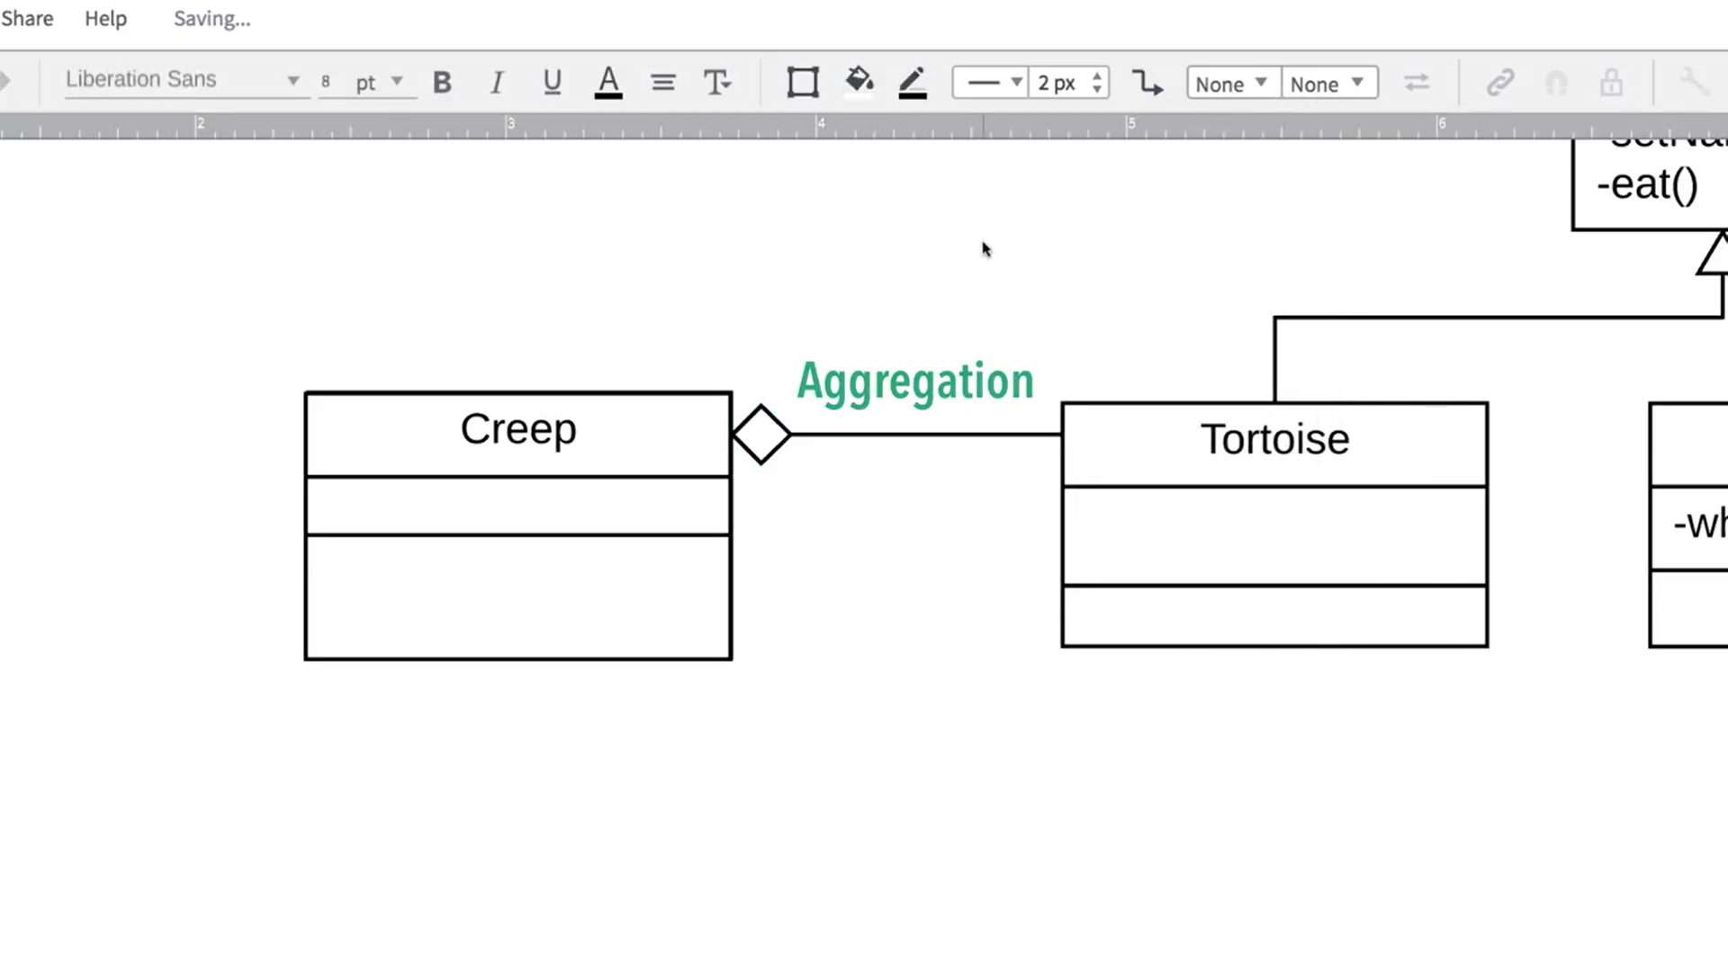

Additionally, there is a relationship called: *Composition.*

To illustrate this relationship we will have to step back from the animals and look at our Visitor Center. A visitor can exist without a lobby or bathroom, but if we tore down the Visitor Center we would also tear down the lobby and bathroom. When a class cannot exist without another class we use Composition

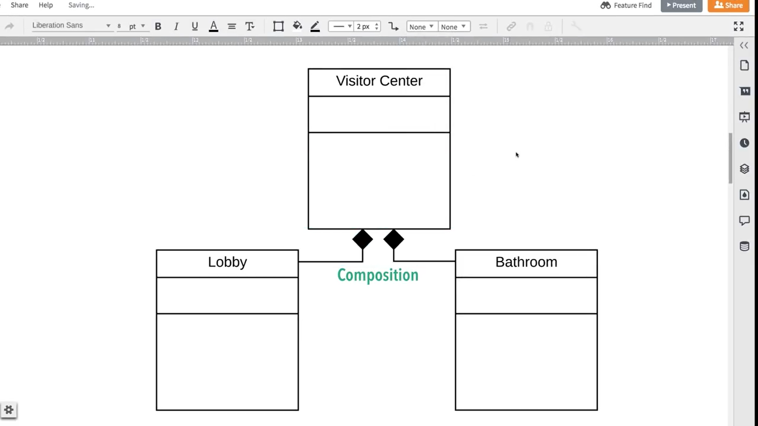

So after knowing these relations we might want to illustrate that there can only be 60 otters in our zoo. This can be done using Multiplicity. Multiplicity allows you to set numerical constraints on your relationships. These constraints are noted in a specific way as you can see in the image below. The Visitor Center can only have one lobby in our class diagram must have at least 1 bathroom, which means it can have 1 to an infinite amount of bathrooms. There are also other multiplicity notations.

* 0..1 means that it can have nothing or one
* n is any number we might want, so in our case we could have 1, this is a variable.
* 0..* means that it can be 0 to infinity
* 1..* means that it can be 1 to infinity
* M…N means that you have to write down in what range you want things to be, m = 10 and n = 50 means that the multiplicity can be somewhere between 10 and 50

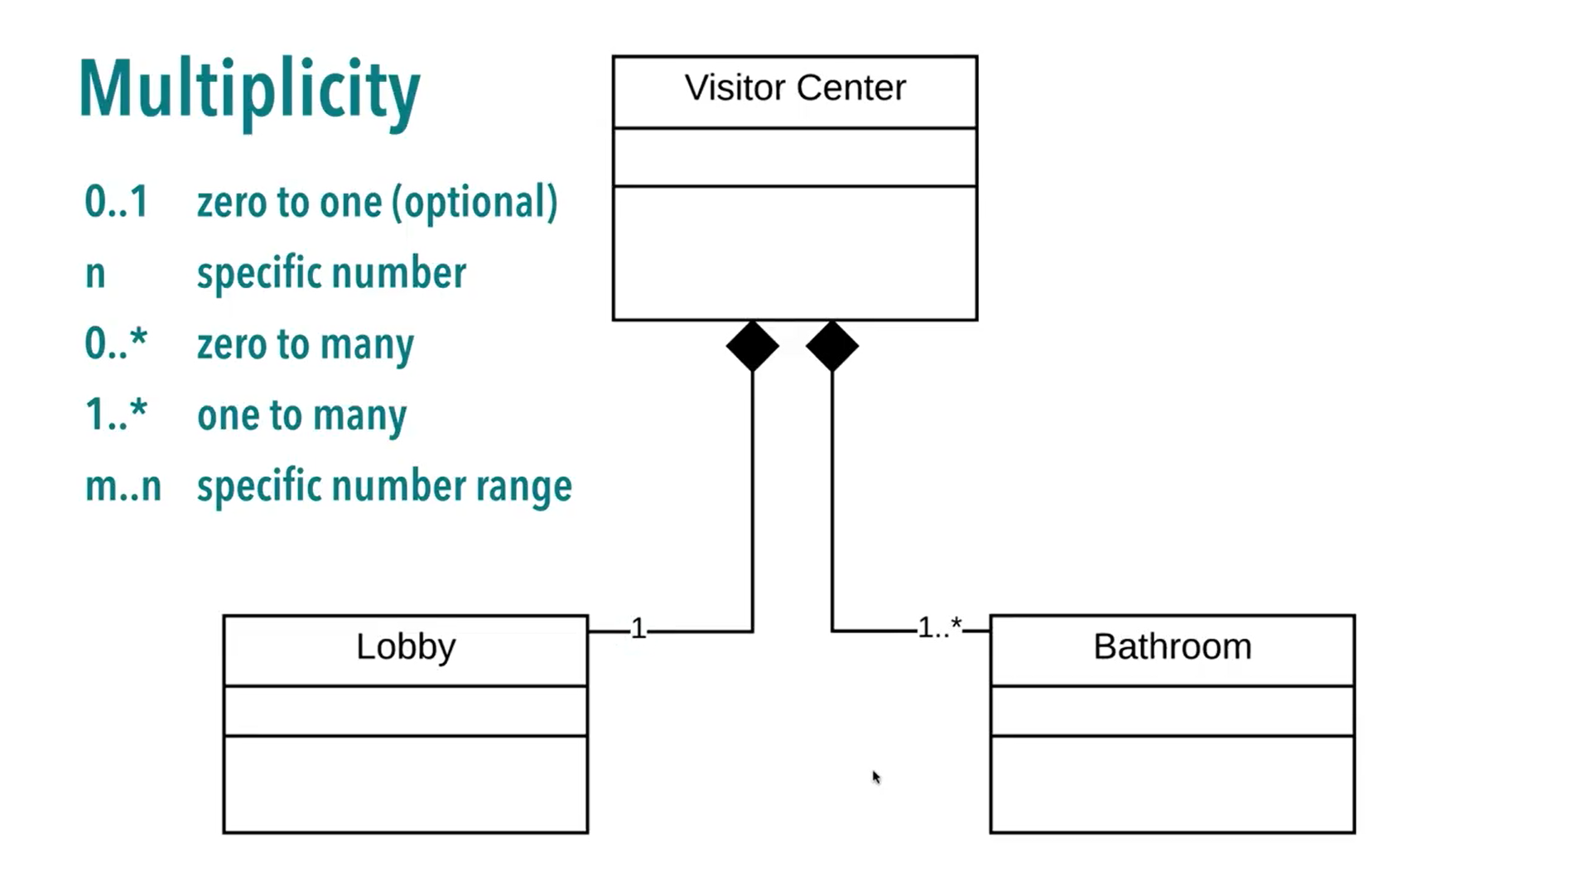

Example diagram (slight edit since the admin couldn’t login):

The diagram below depicts a shopping cart. We will this diagram using what has been written up until now, starting with User.

The User class has attributes that describe the user’s information and its methods describe a way to verify its login status. This information, in turn, can be used by the customer class and administrator. As a user you can also login to your account.

The administrator class inherits everything from User, meaning that it can also login and has a very special set of administrator login credentials. This class can also use the operator UpdateCatalog() class, which allows the administrator to update the catalog for their users.

The Customer class contains information about the user that allows the user to purchase items. It can also use the method updateProfile() which allows it to update its own information and gives new users the ability to register even if there are products in the shopping cart.

Every Customer can have a shopping cart as there are between 0 and infinity shopping carts. Customer has an aggregation relationship with shopping cart which means that if the customer class is no longer there, the shopping cart class ceases to exist. The same thing can be said about order: you can place one order and there can be between 0 and infinity orders going out.

The shopping cart class details a shopping cart that has an ID so it can be easily bound to a customer. It also contains productID, but in this class diagram you can only have one product in your shopping cart. This is due to being unable to fill in attributes as an array. You can, however, specify a quantity of the product you put in your shopping cart. Meaning that you can add an item, update the quantity, view the details of the cart and checkout using methods inside the shopping cart class.

The order class has attributes that are required to place a class. This means you need to input these before you execute the method placeOrder(), the method places an order and gives information to the two other classes (shipping info and order details) which can’t exist without the order being placed and that is the reason for using aggregation.

The shipping info and order details classes are similar, they have different attributes but both take their information from the placeOrder method.

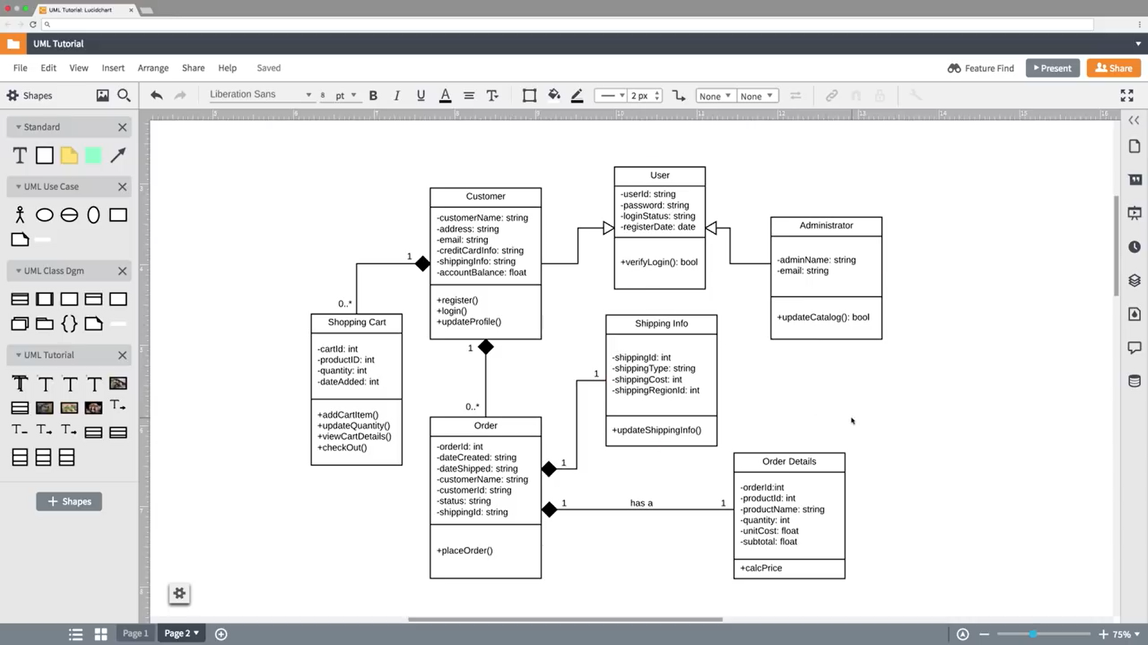

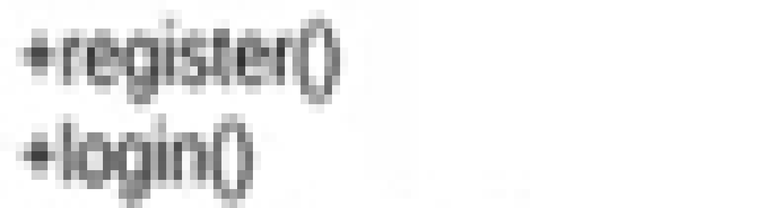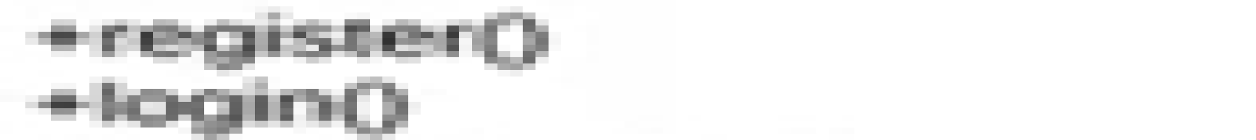

#### **AI Text Summary** (writing, reading, grammar & spelling)

see EDWARD A. FEIGENBAUM.pdf for full text.

**It should be noted that only a portion of the text has been summarized below.**

Humans tend to describe their behaviour as ‘intelligent’ but this is a rather subjective way of describing intelligence. Tests to measure intelligence have all ended in a comparison of test scores to create a scale in which intelligence is measured. To create artificial intelligence we must first define intelligence so that we might recreate it. Obviously we cannot do this, we are only able to grasp it through our own subjective experiences. This means that we will have to make do with the ideal of pursuing artificial intelligence research at the level of human subjective judgment. There is no scientific method that can result in an objective measure of intelligence, despite knowing that intelligence exists. Therefore we should stick to existing methods to define intelligence such a time as a way is found to objectively measure it. This is, in essence, what Alan Turing proposed with regard to testing the thinking capabilities of machines.

The goals of artificial intelligence have been changed over the years by numerous scientists, leading to the following goal:

Artificial intelligence research is concerned with creating machines which show behaviour that, if perceived in human terms, would be defined as intelligent if a human showed that behaviour. This is known nowadays as the Turing test.

These researchers or scientists define human intelligence as simple information processing using the brain and nervous system. They arrived at this conclusion through the scientific method, which includes (but is not limited to) observation, experimentation, analysis, modeling and model validation. Computers, of the general information processing types, can be programmed to carry out most, if not all, information processing tasks that the brain can perform.

There are now two groups, with blurred lines in between them, within Artificial Intelligence research. One of which is concerned with simulating the human brain’s capacity to process information and is more psychologically oriented. The other group is focussed on the creation of intelligent behavior in machines, ignoring the human brain. The theories here don’t need to have anything to do with the human brain. Both of these groups borrow considerably from each other.

The General Problem Solver Program (GPS).

The general problem solver is a program that has been made using the knowledge and ideas from both groups and is regarded as an overlapping program as it takes elements from machine problem solving and also from the simulation of human cognitive processes (thinking). It is a program that allows computers to use a problem solving program which we could associate with intelligence. The GPS consists of an internal core of problem solving processes that are not task-specific, which are then surrounded by information processes and structure for given descriptions and the manipulation of, and the environment belonging to, the task (needed for changing logic expressions). This structure will allow it to try and solve any kind of problem.

The GPS is a program that can solve problems in a specific way. “Given the initial object/state A, a target object/state B and a set of operators/rules which transform objects into other objects. Discover a sequence of operators that will transform A into B”. So if given states a and b exist and given methods for conversion state a into another state, determine how to make state a into state b. This type of analysis is also known as Means-ends analysis.

Additionally, the GPS has a method called “planning”, in which the program tries to discover operators/rules for a problem that has highly simplified operators and objects. It uses the Means-end analysis to solve said problem.

This Means-ends analysis function of the GPS has been used in other programs as well, for example Simon’s Heuristic Compiler, which writes programs using a state language or process-language description of a given information process.

#### Cambridge English Tests

##### Vocab and grammar

The next segment contains pictures from tests that I took at the C1-C2 level, which is the highest available on the website and also the highest available from Cambridge English exams.

The first exercise was grammar and vocabulary:

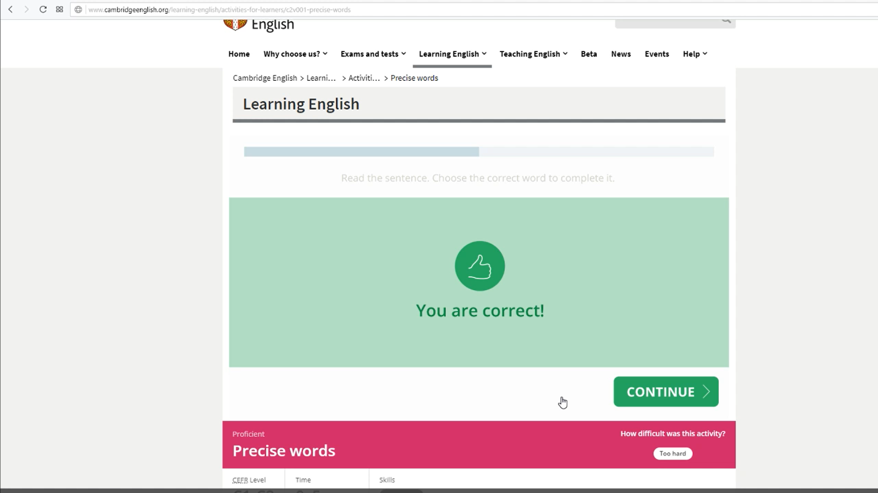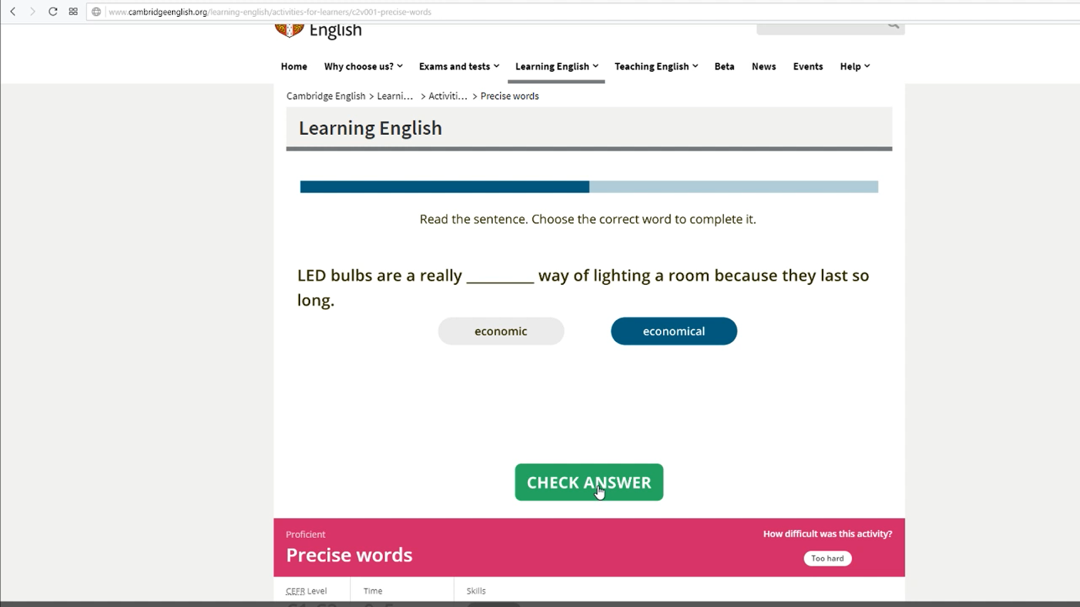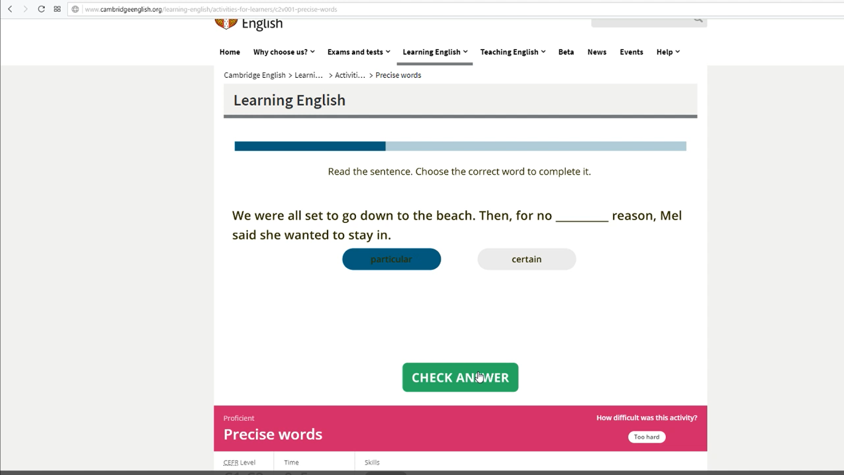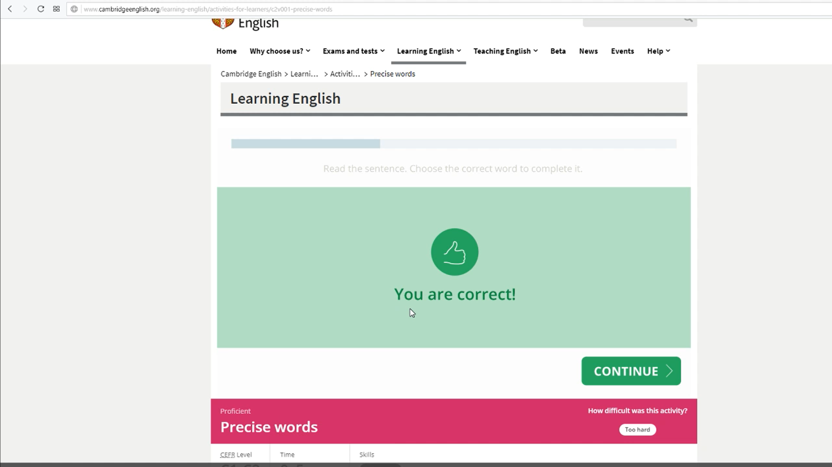

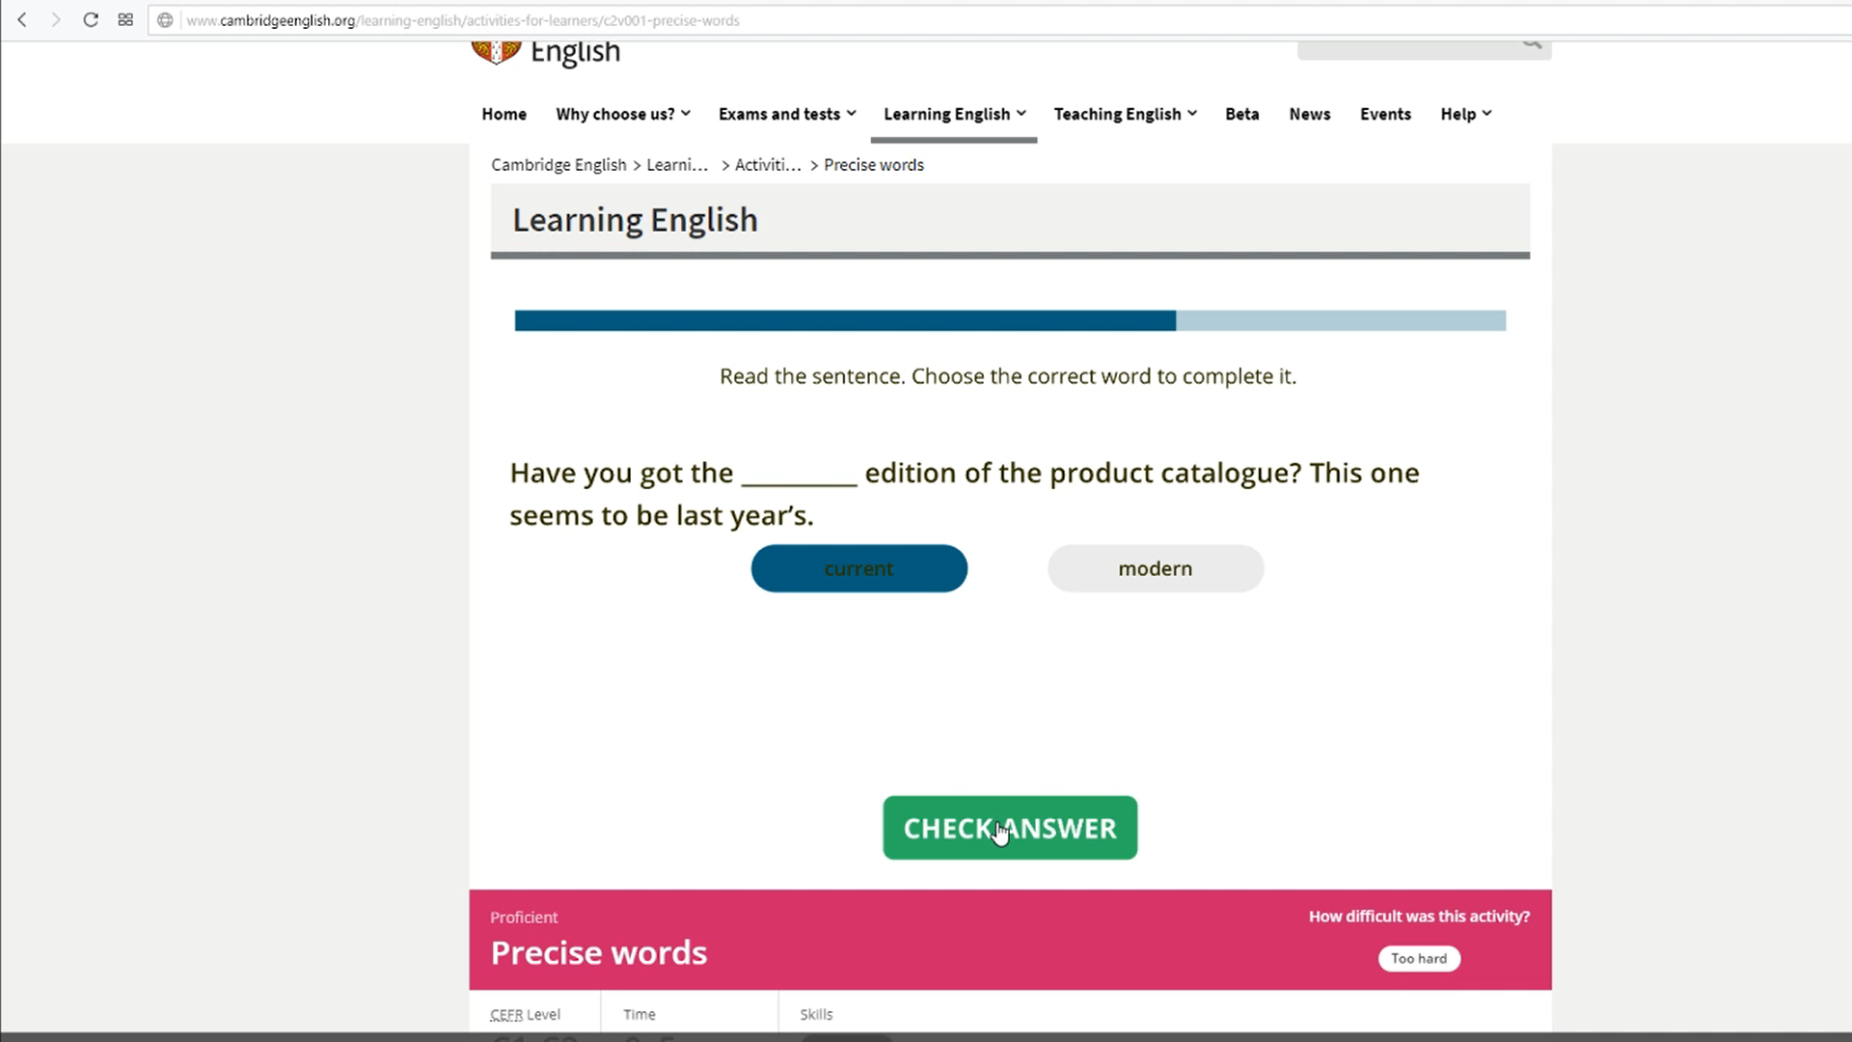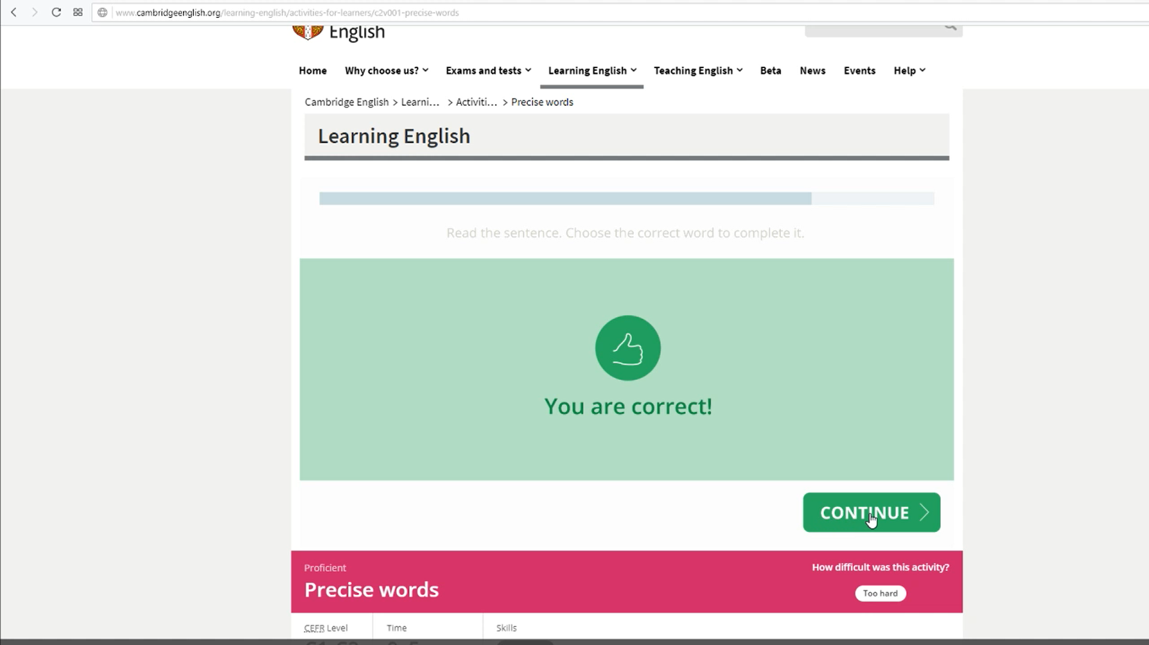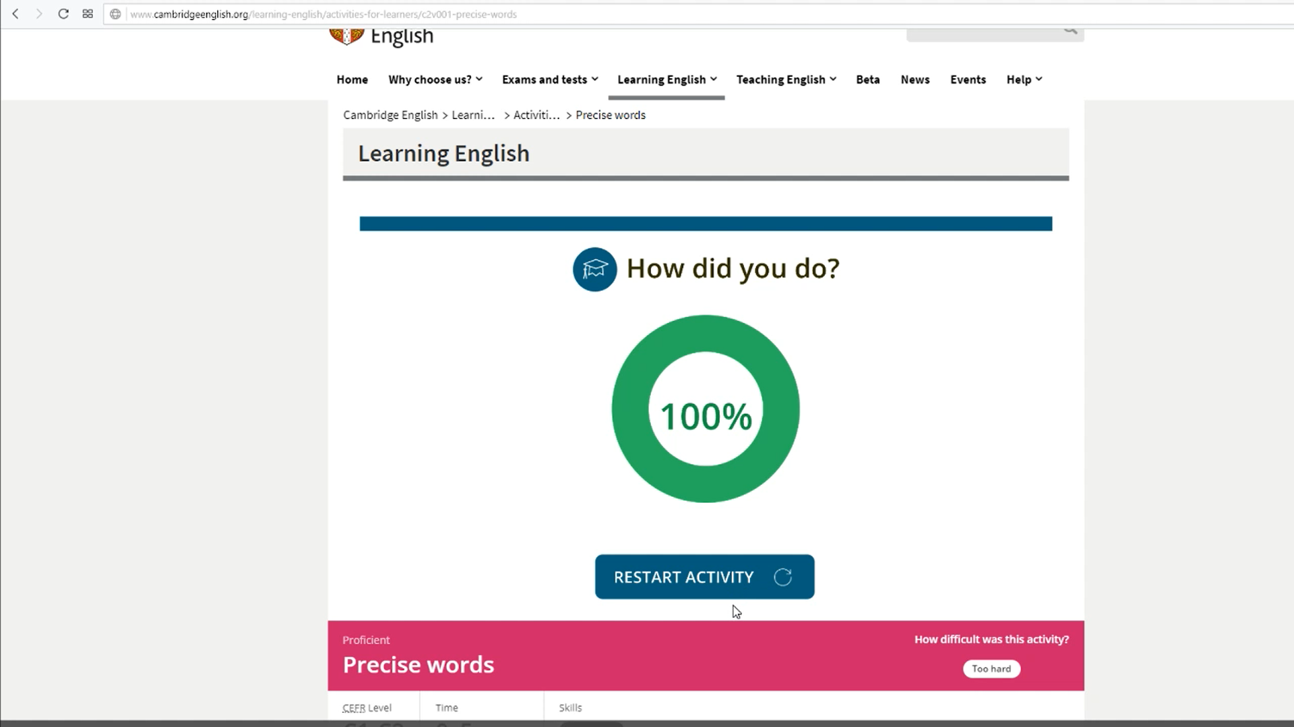

##### 

##### Informal/Formal

Following that, another grammar exercise based around formal and informal words:

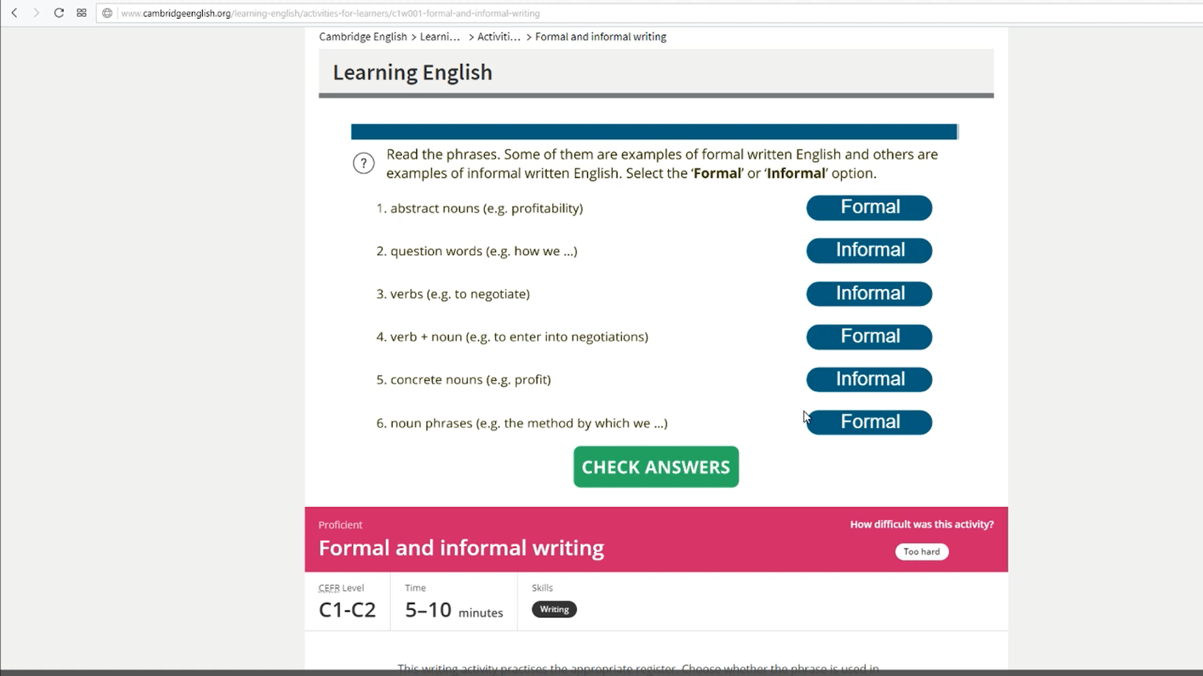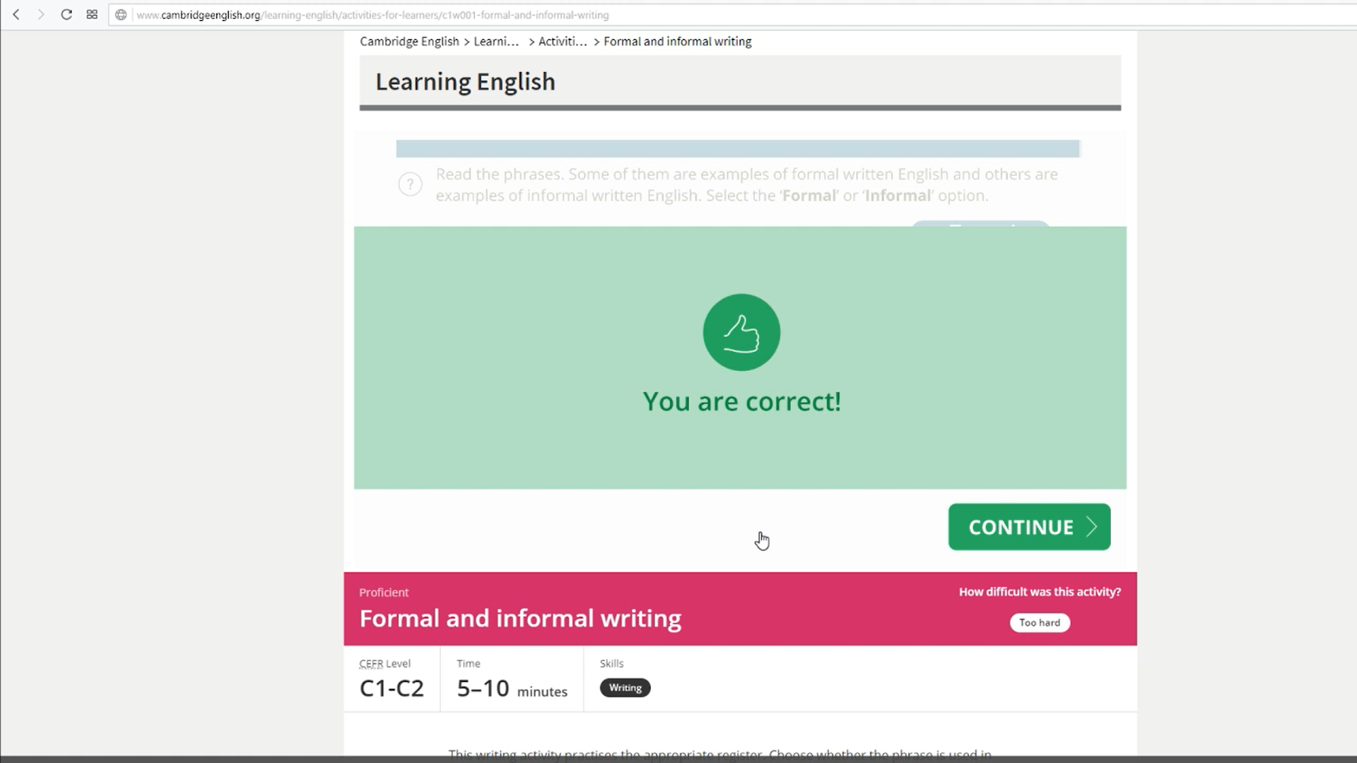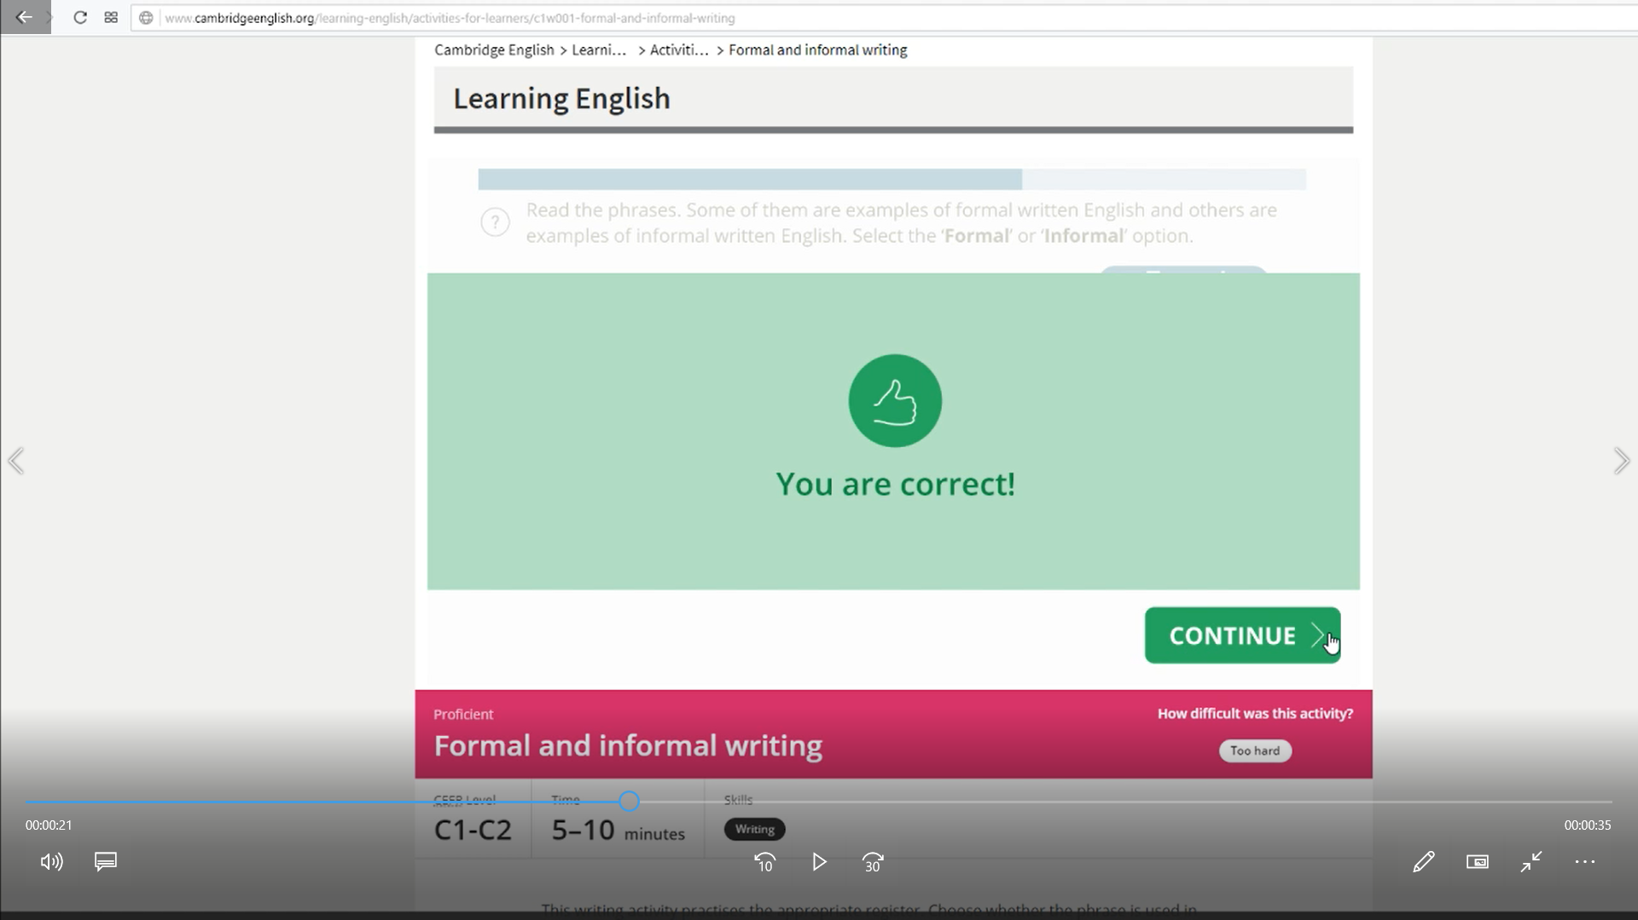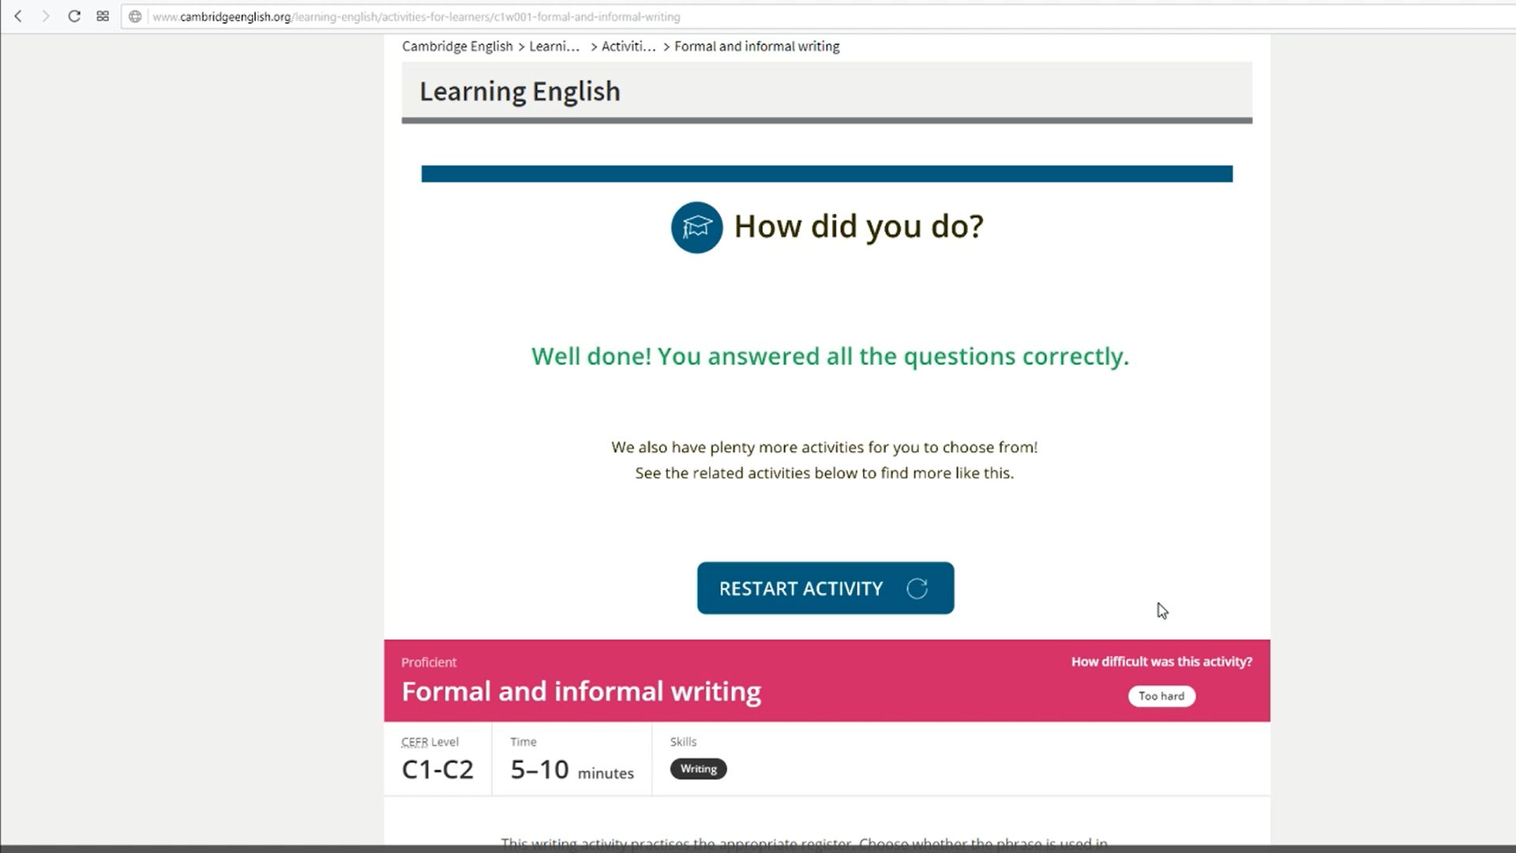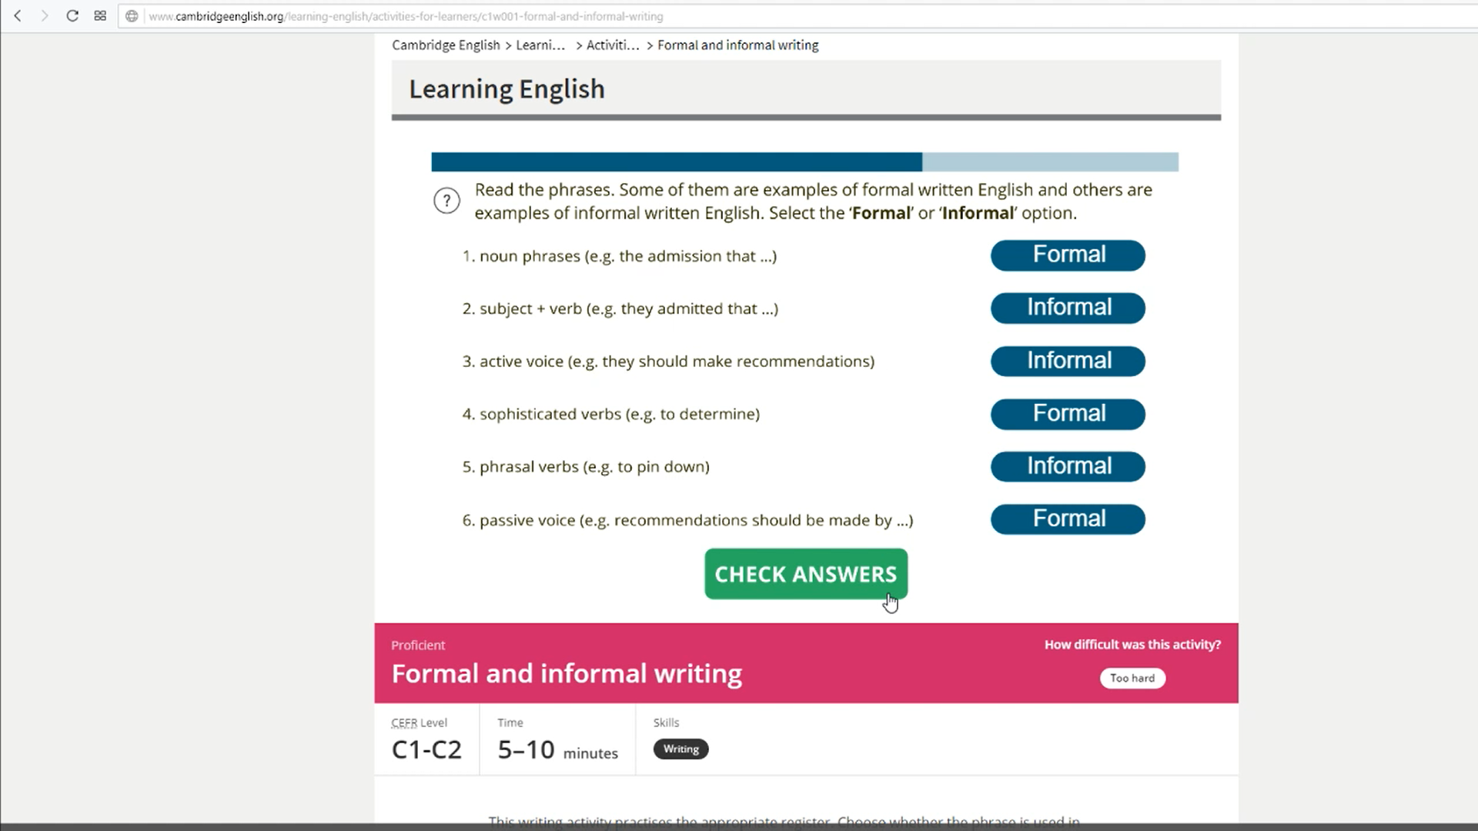

##### which clause

Another grammar exercise, the which clause:

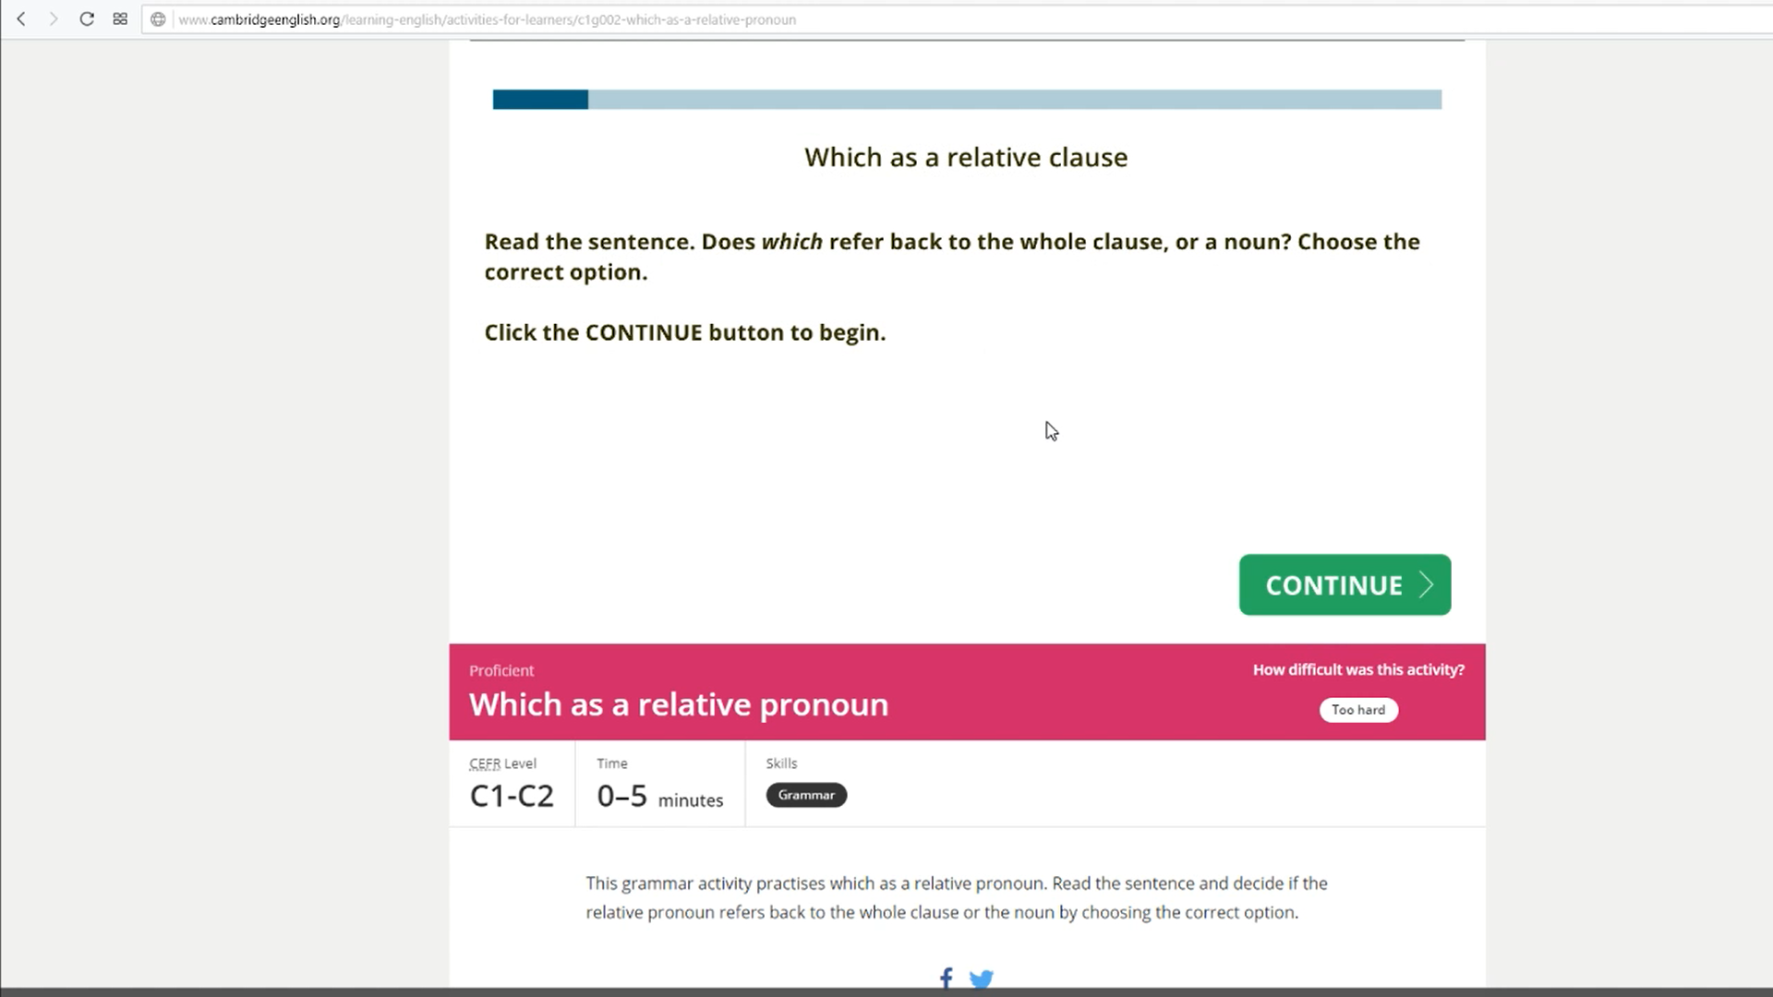

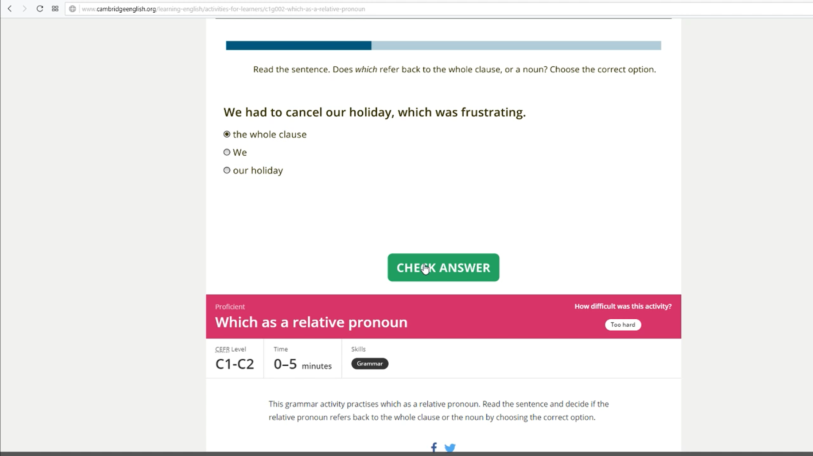

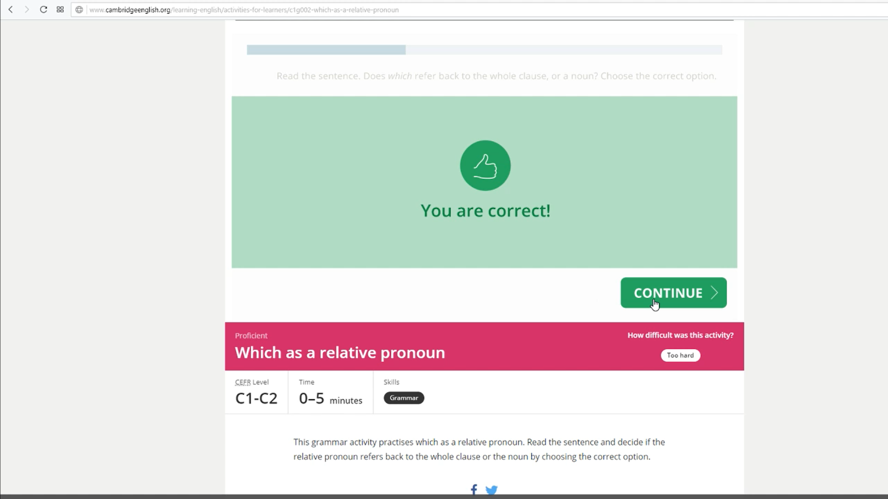

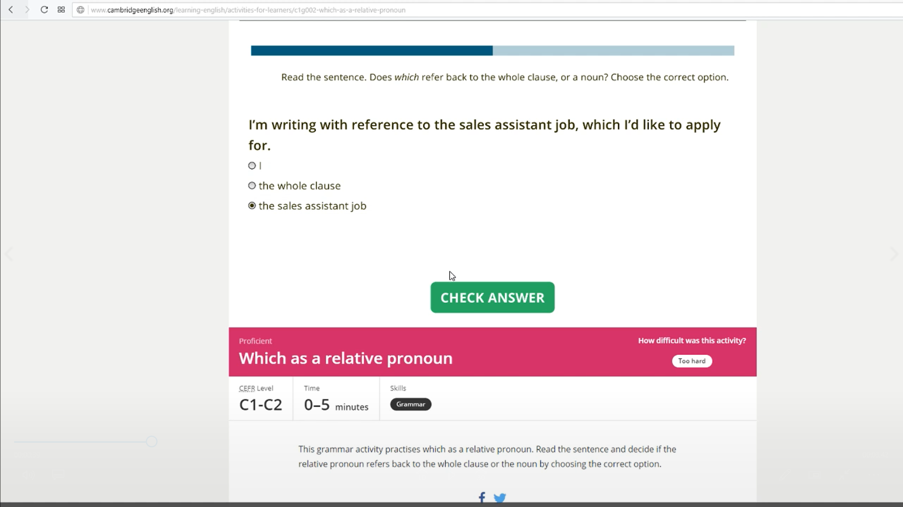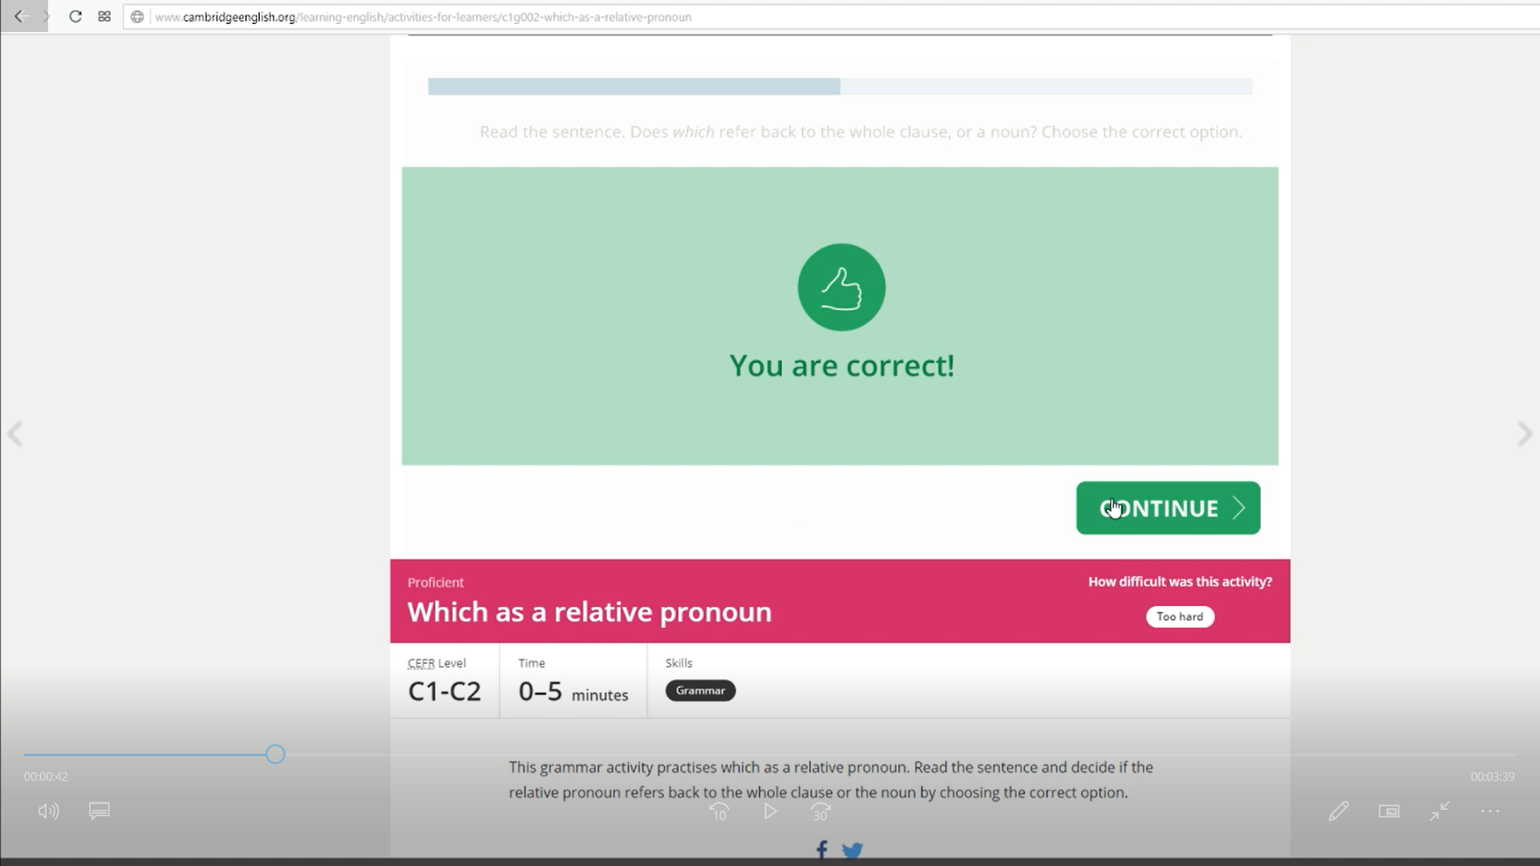

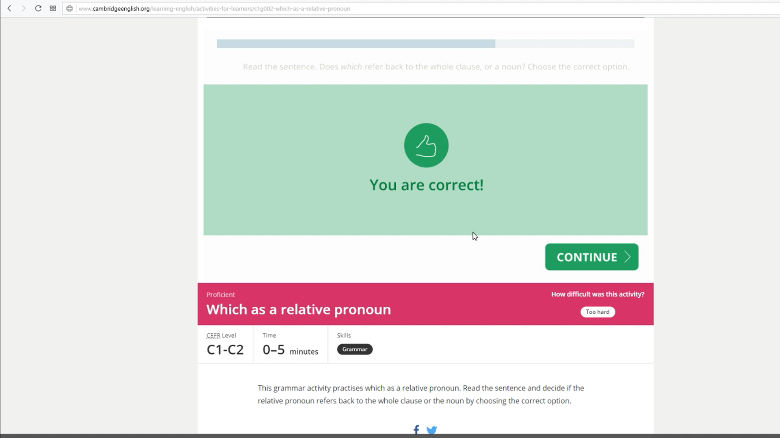

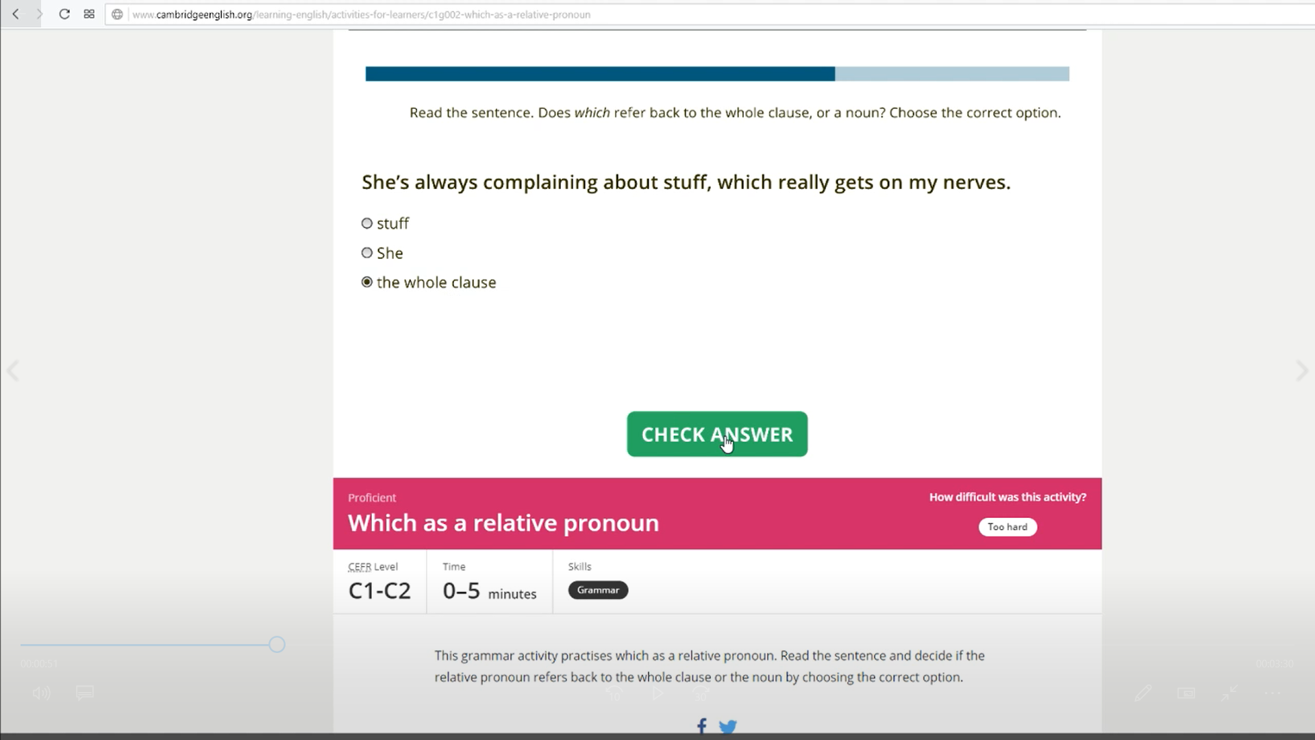

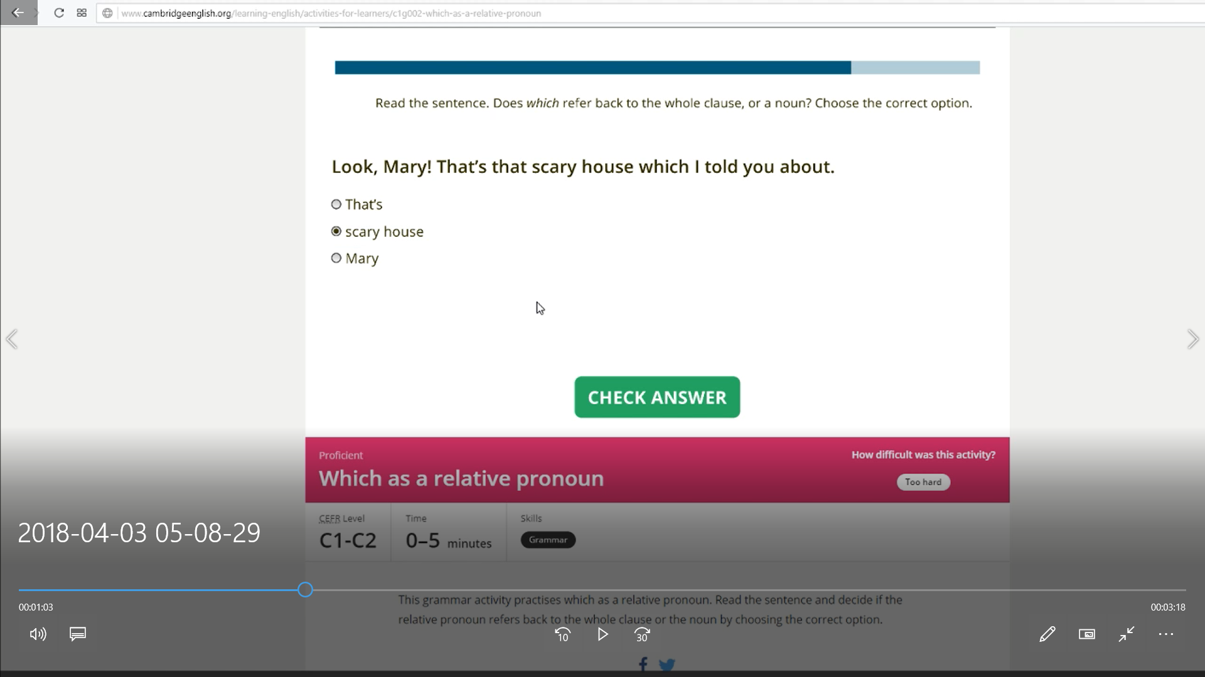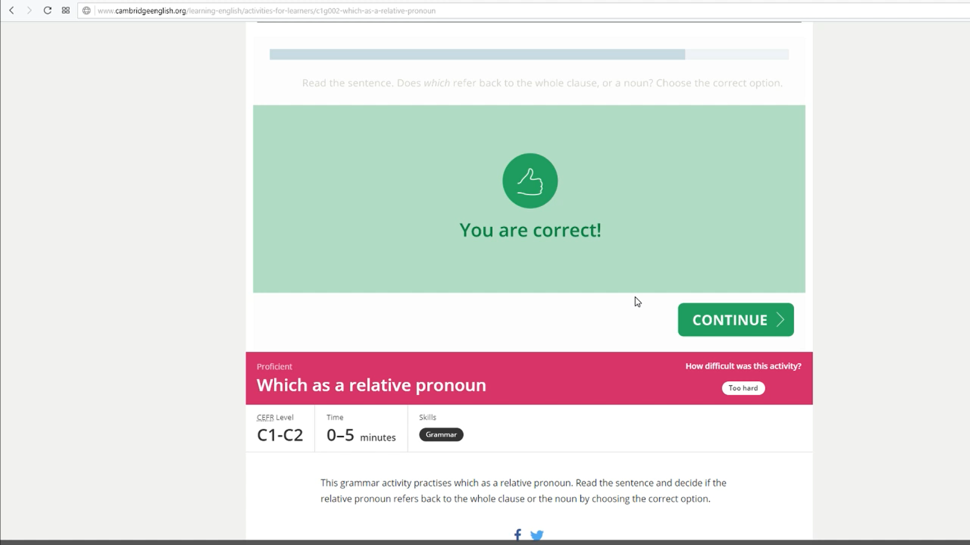

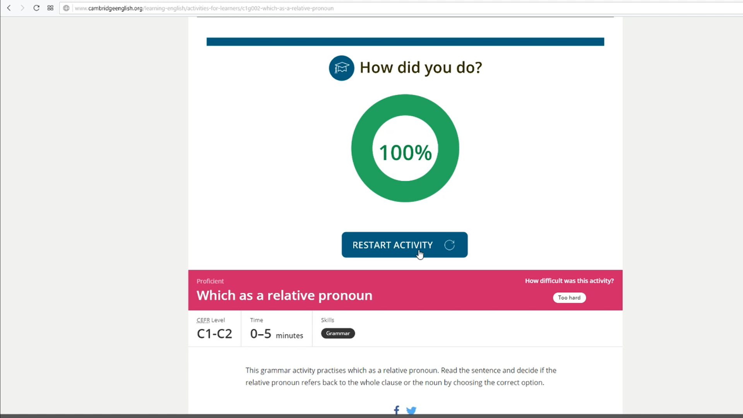

##### 

##### 

##### 

##### Speaking and Reading

Finally, reading, which I did through a video so I could read out loud and demonstrate my speaking abilities. I have provided my speech in the file conversation.mp3, which is included in the attached zip. The video has also been included with the file Reading-out-loud.mp4, included in the video are answers to any questions in the text.